## **Punyashlok Ahilyadevi Holkar Solapur University, Solapur**



***“ Developing software to automatically translate resource materials between English to Indian regional ”***

**A Project Synopsis submitted to the**

**Punyashlok Ahilyadevi Holkar Solapur University, Solapur**

**For the Degree of Batchlor of Technology In**

**Computer Science & Engineering**

**Under the Faculty of Engineering**

**Submitted By**

|  |  |
| --- | --- |
| **Roll No.** | **Name of Student** |
| 16 | **Mr. Mustafa Masuldar** |
| 17 | **Mrs. Sakshi Deshmukh** |
| 18 | **Mrs. Pooja Pawar** |
| 19  20 | **Mrs. Nandini Madre**  **Mrs. Maleka Iram Muchale** |

**Under Guidance Of**

Prof. S.A.Dhanawe

(Assistant Professor)

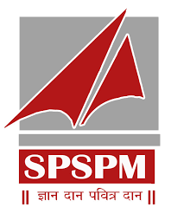

**Department of Computer Science & Engineering**

**N B Navale Sinhgad College of Engineering, Solapur 413255.**

**Academic Year 2023-24**

**N B Navale Sinhgad College of Engineering,  
 Kegaon, Solapur 413255.**

**Year 2023-24**

**SYNOPSIS FOR FINAL YEAR PROJECT**

**Name of the College : N.B. Navale Sinhgad College of Engineering, Solapur**

**Name of the Department : Computer Science and Engineering**

**Name of the Course : B. Tech (Computer Science & Engineering)**

**Name of the Students : 1.**  **Mr. Mustafa Masuldar**

**2.** **Mrs. Sakshi Deshmukh**

**3.** **Mrs. Pooja Pawar**

**4.** **Mrs. Nandini Madre**

**5.** **Mrs. Maleka Iram Muchale**

**Name of Guide : Prof. S.A. Dhanawe**

**Date of Synopsis Submission : 20-October-2023**

**Proposed Dissertation Title : Developing software to automatically translate resource materials between English to Indian regional**

**Abstract**

CIPAM, dedicated to advancing Intellectual Property Rights (IPR) awareness, commercialization, and enforcement, has created extensive educational materials. The software aims to bridge linguistic gaps by translating these materials from English to key Indian regional languages: Hindi, Marathi, Bengali, Gujarati, Tamil, and Telugu.

* The software's core features include its ability to translate various formats, such as Word documents, PDFs, and text within images. Notably, it focuses on maintaining the contextual integrity and professionalism of the original content, ensuring that translations are not only accurate but also accessible to the general public.
* This abstract outlines a comprehensive approach involving Natural Language Processing (NLP) techniques, machine learning algorithms, and collaboration with experts to ensure the software's accuracy and user-friendliness.

**INDEX**

|  |  |  |
| --- | --- | --- |
| **Page Number** | **Title** | **Sr. No.** |
| 5 | Introduction | 1 |
| 7 | Literature Review | 2 |
| 8 | Problem Statement | 3 |
| 9 | Objective & Scope | 4 |
| 10 | Proposed Methodology | 5 |
| 12 | Conclusion | 6 |
| 13 | References | 7 |

1. **Introduction**

* A software solution to translate intellectual property resource materials and texts from English to various Indian regional languages is a commendable initiative for promoting IPR awareness, commercialization, and enforcement. To achieve this objective effectively, the software should encompass the following key features :

1. Translation Capabilities: The software should have robust translation capabilities that can handle different formats such as Word documents, PDFs, and text within images. It should be able to extract text from these formats and translate it accurately.
2. Translation Accuracy: The translation should go beyond literal translations to capture the true meaning of the text. It should consider the context and nuances of the content to ensure accuracy.
3. Language Options: The software should support translation into a variety of Indian regional languages, as specified, including Hindi, Marathi, Bengali, Gujarati, Tamil, and Telugu. Users should be able to select their desired target language.
4. User-Friendly Interface: The software should have a user-friendly interface that allows users to easily upload their documents or text for translation and select their target language. It should also provide options for customization.
5. Resource Materials Accessibility: Ensure that the translated materials are accessible and available for download or distribution, so that they can reach the intended audiences efficiently.
6. Scalability: Design the software to be scalable to accommodate a growing user base and increased demand for translation services.
7. **Literature Review**
8. Title: [Dual Translation of International and Indian Regional Language using Recent Machine Translation](https://ieeexplore.ieee.org/abstract/document/9316016)
9. Title: [Machine Translation Approaches and Survey for Indian Languages](https://arxiv.org/abs/1701.04290)
10. Title: [Tackling Multiway Translation of Indian Languages](https://www.researchgate.net/profile/Rajen-Chatterjee/publication/316110129_Sata-Anuvadak_Tackling_Multiway_Translation_of_Indian_Languages/links/58f0ec810f7e9b6f82de69ee/Sata-Anuvadak-Tackling-Multiway-Translation-of-Indian-Languages.pdf)
11. Title: [Machine Translation of English Videos to Indian Regional Languages using Open Innovation](https://ieeexplore.ieee.org/abstract/document/8937988)
12. Title: [Translation Across Cultures: From The Regional To The Universal](https://thinkindiaquarterly.org/index.php/think-india/article/view/9360)
13. Title: [A Review of Terminological Work Being Done in Indian Languages](https://aclanthology.org/1982.tc-1.17.pdf)
14. Title: [Study on Machine Translation Approaches for Indian Languages and Their Challenges](https://ieeexplore.ieee.org/abstract/document/7955227)
15. Title: [Automated Conversion of English and Hindi Text to Braille Representation](https://www.researchgate.com/profile/Parteek-Bhatia-2/publication/45227432_Automated-Conversion-of-English-and-Hindi-Text-to-Braille-Representation/links/5a6aee20458515b2d05367bf/Automated-Conversion-of-English-and-Hindi-Text-to-Braille-Representation.pdf)
16. Title: [Study of Machine Translation Systems and Techniques for Indian Languages](https://www.researchgate.com/profile/Jatin-Modh/publication/369625759_The-Journey-of-Indian-Languages-Perpectives-on-Culture-and-Society-Study-of-Machine-Translation-Systems-and-Techniques-for-Indian-Languages.pdf)
17. Title: [Machine Translation Development For Indian Languages And Its Approaches](https://www.researchgate.net/profile/Sharvari-Govilkar/publication/276457261_Machine_Translation_Development_for_Indian_Languages_and_its_Approaches/links/5a4ca676a6fdcc3e99d063c9/Machine-Translation-Development-for-Indian-Languages-and-its-Approaches.pdf)
18. Research papers : <https://github.com/Mmustafa-772002/Final-year-Project/tree/main/research%20paper>
19. **Problem Statement**

Developing software to automatically translate resource materials between English To Indian regional languages

1. **Objectives & Scope**

* Objective:
* Develop software for accurate translation of IPR resource materials from English to Indian regional languages (Hindi, Marathi, Bengali, Gujarati, Tamil, Telugu) across various formats, ensuring the preservation of the text's intended meaning.
* Key objectives include accuracy, multilingual support, user-friendly interface, scalability, contextual understanding, customization, quality control, performance optimization, privacy and security, integration, machine learning and AI, cross-platform compatibility, cultural sensitivity, and documentation and support.
* Scope:
* The software covers translation needs for Word documents, PDFs, and text within images.
* The project includes developing software for seamless translation from English to various Indian regional languages.
* The software aims to create a user-friendly interface, preserve the original meaning, and offer customization features.
* Emphasis is on speed, productivity, quality assurance, user feedback, and offline functionality.
* The software extends its capabilities to multimedia content and encourages collaboration.

1. **Proposed Methodology**

Introduction :

The goal of this methodology is to outline the step-by-step process for developing software that can accurately translate resource materials from English to Indian regional languages, such as Hindi, Marathi, Bengali, Gujarati, Tamil, and Telugu.

Proposed Algorithm :

* Input resource material: Text or image file
* Detect language: NLP and ML methods
* Extract text (if needed): OCR for images and videos
* Machine translation: Translate to desired Indian regional language
* Output translated text: Save to file, display on screen, or send to database

Proposed Algorithm Flow Chart :

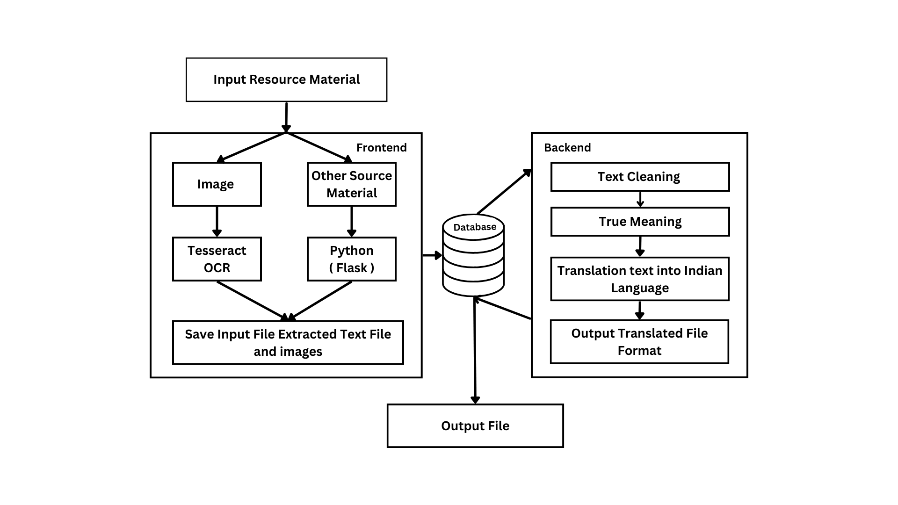

System Architecture :

* Input resource material (text or image)
* Detect language of input resource material
* Extract text from image
* Translate text to desired Indian regional language using machine translation
* Output translated text in desired format

Modules :

* Language Detection Module: This module detects the language of the input resource material.
* Text Extraction Module: This module extracts the text from images and videos.
* Machine Translation Module: This module translates the text into the desired Indian regional language.
* Output Module: This module outputs the translated text in the desired format.

1. **Conclusion**

By implementing the recommended features and considerations outlined in the previous response, this software can become a valuable resource for students, industries, the general public, police, judiciary, and customs officials. It will facilitate not only the translation of content but also the dissemination of knowledge in a manner that is both accurate and easy to understand.

1. **References**

[1] 1. N. Jayanthi, A. Lakshmi, C. S. K. Raju, and B. Swathi, "Dual translation of international and Indian regional language using recent machine translation," in 2020 3rd International Conference on Intelligent Sustainable Systems (ICISS), December 2020, pp. 682-686.

[2] A. Godase and S. Govilkar, "Machine translation development for Indian languages and its approaches," International Journal on Natural Language Computing, vol. 4, no. 2, pp. 55-74, 2015.

[3] N. J. Khan, W. Anwar, and N. Durrani, "Machine translation approaches and survey for Indian languages," arXiv preprint arXiv:1701.04290, 2017.

[4] A. Kunchukuttan, A. Mishra, R. Chatterjee, R. Shah, and P. Bhattacharyya, "Sata-anuvadak: Tackling multiway translation of Indian languages," pan, vol. 841(54,570), pp. 4-135, 2014.

[5] S. K. Pulipaka, C. K. Kasaraneni, V. N. S. Vemulapalli, and S. S. M. Kosaraju, "Machine translation of English videos to Indian regional languages using open innovation," in 2019 IEEE International Symposium on Technology and Society (ISTAS), November 2019, pp. 1-7.

[6] S. Rajani, "Translation Across Cultures: From The Regional To The Universal," Think India Journal, vol. 22, no. 6, pp. 189-194, 2019.

[7] S. K. Dwivedi and P. P. Sukhadeve, "Machine translation system in Indian perspectives," Journal of Computer Science, vol. 6, no. 10, pp. 1111, 2010.

[8] J. Ray, "A review of terminological work being done in Indian Languages," in Proceedings of Translating and the Computer: Term banks for tomorrow’s world, 1982.

[9] D. V. Sindhu and B. M. Sagar, "Study on machine translation approaches for Indian languages and their challenges," in 2016 International Conference on Electrical, Electronics, Communication, Computer and Optimization Techniques (ICEECCOT), December 2016, pp. 262-267.

[10] M. Singh and P. Bhatia, "Automated conversion of English and Hindi text to Braille representation," International Journal of Computer Applications, vol. 4, no. 6, pp. 25-29, 2010.

[11] J. C. Modh and J. Saini, "Study of Machine Translation Systems and Techniques for Indian Languages," The Journey of Indian Languages: Perspectives on Culture and Society, 2019.

Roll No. Student Name Sign

**16 Mr. Mustafa Masuldar**

**17 Mrs. Sakshi Deshmukh**

**18 Mrs. Pooja Pawar**

**19 Mrs. Nandini Madre**

**20 Mrs. Maleka Iram Muchale**

(Prof. H. T. Gurme) (Dr. D. P. Gandhmal)

Guide Head of Dept. (C.S.E.)

Place: Solapur.

Date: 20-Oct-2023